Annual Report

Wide Angle
Social Development Organisation

April 2019 – March 2020
Annual Report for Wide Angle Social Development Organisation
for the period of April 2019 – March 2020

Staff Meeting:
On 12th of April 2019, a Staff meeting was held at Wide Angle Office. The agenda of the meeting was to discuss the Plan of Action and other miscellaneous things. During the meeting, the staffs share obstacles and challenges they face while conducting the program as they find it hard to cover the targeted nos. of students as in Hill districts the maximum strength of student per school were 200-400 students in total that is also only 1 or 2 schools. And there were no halls and class rooms were small, only 150 students at maximum can sensitize. Also there was a long distance between the schools so they sometimes expenses on their own while travelling as the budgets was insufficient. The geographical area in hill districts was large and unable to cover in short period of time. So they request to deduct the targeted nos. of children. Ukhrul also shared that they don’t one to confine to only Ukhrul town.
WIDE ANGLE Staff meeting with CRY
On 7th of June 2019, a Staff meeting was held at WIDE ANGLE office. The agenda of the meeting was to discuss the programmes which has been conducted so far and to discuss the programs which have to be done during the next Quarters. All the staffs were present during the meeting.
During the program WIDE ANGLE coordinator share on the program which had already conducted and the plan of action that was to be conducted . The outcomes of the meeting are –
- Issues on establishing of child friendly police station in 5 places was minutely discuss and it was decided that S. Sarat Sharma, former Chairperson MCPCR will head the team comprising of senior member WIDE ANGLE will visit 3 PS of 3 districts viz, Chandel, Kangpokpi and Imphal east. The members will have an interaction with the SP concerned and request to establish a child friendly Police Station as per the order of High Court.
- The Child Policy which has been lying idle despite the promised made by H’nble Chief Minister Shri Nonthongbam Biren Singh & Ho’nble Governor of Manipur Dr. Najma Heptulla on public domain. It was decided that a student of Mass Communication, Manipur University will be assign to highlight the importance of Child Policy in the state through media. The senior’s members of WIDE ANGLE will met Law Secretary, Principal Secretary, Under Secretary of Social Welfare Department and others Govt. Officials in order to carry out the draft policy at Cabinet. It was decided to hold a consultation on children policy in the month of July. All the required materials will be prepared by Pradip Keisham with the consultation of officials staffs of WIDE ANGLE.
- Formation of VLCPC, Hill districts consultations of JJ/POCSO Act and others plan programs were also discuss during the meeting.

Coalition Meeting with District partners
A Coalition Meeting was conducted along with district partners 4th March 2020, the meeting was focused on the action plan for the next Quarter and to bridge up the gaps in responses from districts which was felt in recent times. It was also discussed to speedy up the activities and try covering the plan of action before the end of 31st March 2020.

WIDE ANGLE Annual review Meting
WIDE ANGLE Annual (2018-19) review meeting was held on 7th & 8th August 2019 at the administrative office of WIDE ANGLE. The meeting was held with the presence of Ms. Mahua Chatterjee, Mr. Ashim Gosh, General Manager and Assistant GM CRY respectively along with the members of WIDE ANGLE from the eight districts. Mr. Montu Ahanthem, Secretary WIDE ANGLE gave a warm welcome to all the members present. The Media interns were also invited on the onset of the Review meeting.
Mr. Ashim Gosh gave a warm welcome to all the media interns and asked them to share their experience. There was a session of sharing of heartfelt enthusiast experience by the media interns and thereafter the Certificates of the internship were distributed by Ms. Mawa Chatterjee, Mr. Ashim Gosh, Mr. Montu Ahanthem and Mr. K. Pradip. The names of the students who had received the certificate are-
- Keisham Damaru Singh assigned at People’s Chronicle
- Ningreichon R. Shimray assigned at People’s Chronicle
- Hoijjahat Gangte assigned at Imphal Free Press
- Livine Khrozhoh assigned at Imphal Free Press
- Dineshwar Phuritsabam assigned at Imphal Free Press.
Ms. Menaka, the Assistant Coordinator gave a PPT presentation on the entire activity inputs and outputs for the year 2018-19 till date. The Ukhrul District correspondent Ms. Sony brief on their annual activities and achievements. Likewise all the district members add on their achievements and challenges.
During the meeting the achievement/outcomes of the project year 2018-19 were discussed thoroughly and also projections were discussed for the next project year. Core Member Mr. K. Pradip suggested to advocate the need of an ambience for Child Friendly Court as the present scenario of the court is susceptibly uncomfortable for a child to attend. The highlighted of the meeting:
- A total of 17 Child friendly PS were open at different districts of Manipur in 2019.
- Nos. of VCPC formed in 2019 are -
1. Thoubal - 2
2. Bishnupur - 5
3. Chandel - 19
4. Senapati - 3
5. Ukhrul - 29
6. Churchandpur - 10
On the 2nd day of meeting, Ms. Mahua Chatterjee, General Manager CRY gave a PPT on SAG and suggested to develop the said programme in the context of Manipur State. The members present in the meeting felt that the said proposal shall serve very useful for the adolescent girls of the State.

Ms. K. Pradip share warm news that the application submitted to the MHRC has been respondent and the Dept of Social Welfare s aske to put in action within 4 weeks time.
Submission of memorandum to Manipur Human Right Commission to take up steps to adopt State Child Policy and to provide immediate Psycho-Social Care and Support to the 36 minors who happened to be the
POCSO Case Report (2018-19)
Sl.No | District | FIR | Charge sheet | Interim | Final
 | Imphal East | 29 | 14 |  | 9
 | Imphal west | 28 | 19 |  | -
 | Thoubal | 10
 | Bishnupur | 21 |  | 13 | 3
 | Chandel | 7 |  | 4 | 1
 | Senapati | 3 |  | 1 | 6
 | Ukhrul | 11
 | Churchandpur | 3

Trafficking Record (2019)
Sl.No. | District | Prevention | Rescue
 | Imphal East | - | -
 | Imphal west | - | 124
 | Thoubal | - | -
 | Bishnupur | 3 | 3
 | Chandel | 7 | 64
 | Senapati | NIL | NIL
 | Ukhrul | NIL | NIL
 | Churchandpur | NIL | NIL

17.. Imphal west,, pocso data
17th August.. bishnupur kids,,
19. pocso data Imphal east
26 State working Commitee Meeting
IIIrd Quarter Review Meeting
The third quarter review of WIDE ANGLE was conducted for 2 days on 17th to 18th February 2020, the State coordinator gave a power point presentation on the plan of action of the year and focused on the IIIrd quarter of the Action Plan and the activities undertaken, as the input and the output of the activities. During the review meeting the pending activities were also brought up and to expedite the pending inputs.

MEDIA INTERNSHIP
Launch of Media Internship Programme in Manipur
On 8th of April 2019, at WIDE ANGLE Office a media internship programme was launched for the first time in the state along with Manipur Alliance for Child Rights with an objectives to inculcate in the students a sense of responsibility towards the society, orient them about media ethics and give them a platform to hone their writing and investigative skills and express their views on important issues related to children in the state. The programmed was conducted through a ZOOM Call with representative from CRY, intern students, Convenor MACR and members of WIDE ANGLE. 3 participants from CRY namely, Trina Chakrabarti, Ashim Ghosh, Nilanjana Sen Dasgupta from CRY, Kolkata, 4 intern students from College of Social Work and 1 from Indira Gandhi Tribal University, Manipur Campus and members of WIDE ANGLE and MACR were present during the program.
The program starts at 11am with a welcome note by Montu Ahanthem, Convener WIDE ANGLE and then followed by a self introduction from all the participants. The program was anchored by Nilanjana of CRY, Kolkata. Then Mahua Chaterji delivered few words on CRY (Child Rights and You) that they have been working for 40 years in Child Rights and she points the word “YOU” in the name of their organization Child Rights and You that YOU refers to all of us, to all the human beings. That everyone is responsible in protecting the Rights of the Child.
After her, Ashim Ghosh narrates on CRY’s work and journey in Manipur. He stated that CRY starts working in Manipur in the year 2005, impacting the lives of the people affected by the armed conflict. They also worked in the issues of the govt. schools like non-functioning of Govt. Schools, unavailability of teachers, improper structures, maintenance etc. They also worked with the Manipur Mahila Kalyan Samiti, the Children Home in the state. By 2013-14, they started working on Right to Education, trafficking issues and Sexual assault cases on Childs till today.
Then PradipKumar Keisham, member MACR conveyed about the changes in the situation of Child Rights in the state after intervention of CRY. There was none working for the Child Rights during that period and WIDE ANGLE and MACR was the first body to starts working on Child Rights in Manipur. At present, the major issues on Child were trafficking, sexual assault, early child marriage, child labour etc. Talking about the roles of Media on Child Rights, he pointed that media publish only the report of the incident- when and where it happens only. They skip to publish the causes of the incident, how and why it happens, what happens to the victims afterwards, how it can be solved and status of the conviction rate. So he concluded that through this program, the unreported issues and stories will be published through media and the intern students can learn and experienced about the media ethics, writing skills, status of Child Rights in the state and the opportunity to speak out their minds.
Between this, Nilanjana asked Montu to give his ideas on current status of Media House in Manipur. Montu suggest that the media plays a vital role in the society. There were brave journalists who have published the bitter truth of the society without any delay and there were some who are always mute as they might be afraid of the higher authority. He sets an example of Wangkhem Kishorchand, who has been jailed for about 4 months for criticizing the government.
Later Nilanjana explains about the programs that the period of internship will be 1 month. She advised the students to strictly follow the Do’s and Don’ts while working at the Media House. Only to take the interviews (if needed) when the interviewee is ready and feels comfortable. The students are asked to contact with her or Pradip kumar if there is any questions or doubts. The findings and reports are not allowed to share to another third party or on social media. And this will give the students to learn and experienced a lot of things which will be helpful in their career she further added. Each student has to publish 2 articles during the internship period. And the theme of the articles should be one from the topic given below-
• At least one article on child-related issues in Manipur within the duration of internship (Secondary data can be used)
• One article on an ‘everyday hero’ (Help may be taken for information and inputs from CRY partners in Manipur)
• One impact story on children from project area (Help may be taken for information and inputs from CRY partners in Manipur)
The expenses incurred by the students will be reimbursed by CRY after the project.
Afterwards a group discussion was done and students were assigned to work to three different media houses, viz.The Sangai Express, The People’s Chronicle and The Imphal Free Press.
Sl.No. | Media House | Assigned Student
1 | Sangai Express | Surma & Nelson
2 | People’s chronicle | Baldev & Dinju
3 | Imphal Free Press | Dineshwar

The program was concluded by having light refreshment after Nilanjana gave a conclusion speech.
Meeting with Intern (1st Batch)
A meeting with intern was held at the WIDE ANGLE office along with MACR on 11th April at 2.P.M. The interns inform that that the program which CRY provided to them will not be able to follow as they have an exam next month and they have to submit paper for the said exam. They inform us that they will be able to work only for twice in a week and want to submit only 2 Article. So Pradip inform them, that to provide us the date which they want to come. As per the information provided by the interns Menaka will make a program schedule as per the earlier one which CRY provided.
Another meeting with intern was held on 20th April at the office of WIDE ANGLE headed by Keisam Pradip Kumar of MACR in order to plan for field visit and also to share their engagement with media houses. At the end of the meeting the interns had a telephonic interaction with Nilanjana.
Intern Field Visit(1st Batch)
WIDE ANGLE and MACR had organised a field visit for CRY intern on 25 and 27th April 2019 at Senapati and Chandel with the support of CRY. The visit for Senapati was headed by Keisam Pradip and for Chandel it was headed by Somaj Sharma. On the first visit the interns were taken to Village community hall, Namgailong Rongmai where a school has been set for temporary as there is no school building. The interns had interacted with Dingmai Golmei, Village Secretary and shared about the process which Wide Angle has been trying for the govt. to construct the school. After that they had a interaction with Solomon, Pastor, New Eden and shared that Wide Angle have been taken a major role in sharing the act, schemes which are mean for children and appreciated WA for giving livelihood training to the village youth and also shared about the problem faced by the village. Lastly Themore also shared about the role and the works taken up by WA in these villages and also inform about the steps which they have taken up to formed VLCPC.
Then at Chandel, the intern was taken to a Shalom English Academy for awareness on Break the silence and they had also interacted with the children. After the campaign Darngam informs them this is also one of the programs which NEEDS have taken up to sensitise the student and the teachers on child sexual assault. After the school visit the team went to the office of NEEDs where we meet the secretary Angshem Tongtang. Angshem shared about how they have set the organization in the year 1993 and the reason for setting up, he further inform about the conflict between Naga and Kuki. He shared about the vision and mission of the organization and the works they have taken up together with WIDE ANGLE. He describes the activities which they did to achieve to get their vision and mission and also shared many cases which they have taken up. He also shared about the hierarchy from the grassroots level where NEEDS work then WIDE ANGLE then CRY and so on.
At the end interns shared that they have learn many thing form this visit. They inform that the information/knowledge which the organization provides is more than their expectation. The program ended with light refreshment.
Meeting with HOD of Mass Communication Dept. Of MU for Internship Programme
On 28 of May 2019, WIDE ANGLE staff with MACR met with Ma’am Meena Devi, Head of the Department of Mass Communication Department of Manipur University regarding the Media Internship Programme. She has assigned 2 students each to Poknapham & Imphal Free Press. The selected names of the student’s are –
- Keisham Damaru Singh
- Ningreichon R. Shimray
- Hoijjahat Gangte
- Livine Khrozhoh
2nd Batch Media Internship with CRY & Media House
An interaction with the new intern students was conducted on 29th of May 2019. Montu Ahanthem, Convener of WIDE ANGLE talked a brief story of how WIDE ANGLE was formed and about working with the CRY. Later the students fill up the questionnaire set by the CRY and discussed about the intern program and schedules.
Interaction with Media Intern(2nd Batch)
WIDE ANGLE had an interaction with the intern student from Manipur University and Amity University on 1st June 2019. The main objective of the interaction is to inform the intern the basic child rights scenario and to share the purpose of doing the internship program by CRY and WIDE ANGLE with Manipur Alliance for Child Rights. State Coordinator MACR shared on the role MACR E and works which has been taken up by MACR and its partners. First they were highlighted basic idea of POCSO, JJ Act, and RTE Act etc. They also brief about the issues of trafficking and were shown and tell them to analyze the paper cutting which MACR have collected so far.
Then Keisam Pradip, Member, MACR also brief about the media ethics and dos and don’ts while writing report on children issues. After that he thoroughly brief about status of Children in the State of Manipur and the role WIDE ANGLE has taken up so far. At the end the interns from Manipur University were given a topic to focus and to write at least one paper on the issues.
- Keisam Damaru – Draft Manipur Child policy
- Ningreichon R. Shimray - Trafficking
- Hoijjahat Gangte - VLCPC
- Livine Khrozhoh- VLCPC
Interaction with Intern (2nd Batch)
WIDE ANGLE had a 3rd interaction with Intern along with Ashim Ghosh, CRY, Kolkata and all the district partners. The interaction started with a self introduction amongst the participants. Ashim shared on the functioning, Role and responsibilities of Child Rights and You and how they supported WIDE ANGLE as well as MACR. He briefs the student that while he was returning from Chandel yesterday on the occasion of Id, he saw many children holding toy gun which exactly looks like the real one. He explains the reason behind the children holding the toy gun as Manipur has been an arm conflict area for long, where they saw police, Army or unlawful organization holding gun and thought they are very powerful person. He explains that this is the negative impact into the child psychology. Instead of demanding gift like Dictionary, Soft toy etc. during the festive season they started to demand toy gun which they think those person which hold gun are powerful and wanted to do the same. This led to many children in early years where many children join underground party. He also explains how WIDE ANGLE and MACR worked on this issues and appeal to unlawful organization not to recruit children through media.
After the interaction the intern had exclusive secession with Ashim, S.Sarat, Pradip, Angshem and the staff in order to familiar with the topic which they were given.
Intern from Amity University, Noida at WIDE ANGLE
A two intern from Amity University namely Mr. Chinganbam Ningthilsana and Mr. Roshan Kamei a student of political science 2nd Semester, M.A were sent to WIDE ANGLE for their summer internship for 5 weeks in order to understand the basic child rights issues, the functioning of WIDE ANGLE and other social issues. The objective of the internship is to enable and to integrate knowledge in practice application, develop skills and acquire some experience.
Certificate distribution
On 7th of June 2019 WIDE ANGLE along with CRY, Kolkata and MACR had distributed Certificate to Eloni Khwairakpam, student of MSW, Assam Don Bosco University, Guwahati who completed interned with CRY for a period of four weeks from 25th February 2019 to 23th March, 2019. She undertook an assignment document on “A status on POCSO in the State of Manipur".
Her internship comprised of formal orientations on development notions, studying POCSO cases in Manipur, analysis of media news, Child Welfare Committee data and report writing.
During the certificate distribution all the district partners of MACR and WIDE ANGLE were also present. MACR State Co-ordinator briefs the participants about the report which the intern have taken up and also inform that this report had already publish in Poknapham and People’s Chronicle . Afterwards intern shared that during her tenure in WIDE ANGLE, she had learned many issues related with Children in regards to Manipur and the various roles which WIDE ANGLE, MACR with support of CRY have taken up so far. She thanked Ashim Gosh MACR and WIDE ANGLE & all the stakeholders for providing the knowledge and helping her to complete the report.
The Certificates was handover to her by Sarat, Montu Ahanthem & Ashim Gosh.
Press release on Media Internship
WIDE ANGLE had a press release on media internship on 9th April 2019 that for the first time in the region, CRY- Child Rights & You has launched Media Internship in Manipur State. Main objectives of the initiative are to orient the young talented students about journalistic writing skills, media ethics and to enable them to express their views on crucial issues related to children in the State.
In the first batch of the 4 weeks long Internship, Six students nominated by “Indira Gandhi National Tribal University” (IGNTU) Manipur Campus and “College of Social Work”, Imphal West are being oriented by three esteemed Media Houses namely “The Imphal Free Press, “The Sangai Express” and The People’s Chronicle”.
As a part of the internship – media trips and field visits will be organized by WIDE ANGLE and MACR to Child Rights Project Area undertaken by CRY partners in Manipur in different districts.
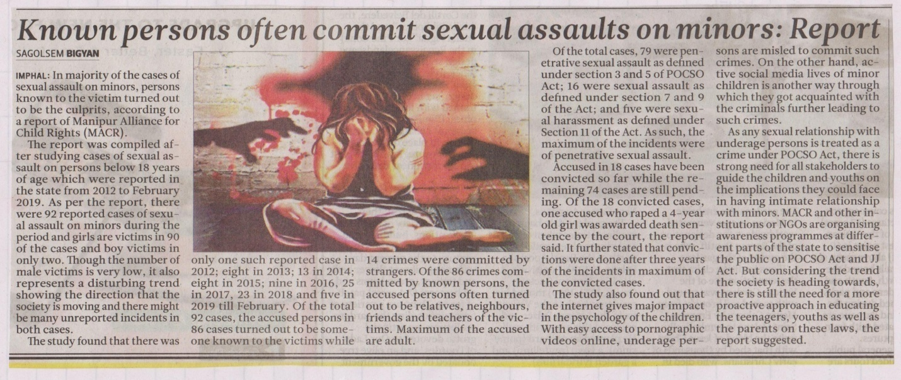
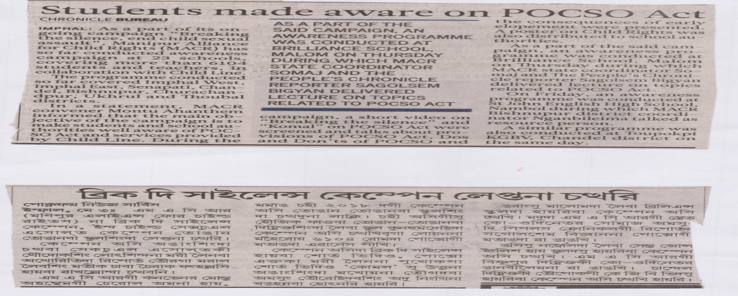
Media report on child sexual abuse : WIDE ANGLE and MACR report on child sexual assault by intern was published on People Chronicle on 2nd April 2019 and Poknapham on 12th April 2019 on the headline “Known persons often commit sexual assault on Minors”.
Press released on Break the Silence Campaign
A press note was released on the ongoing “Break the Silence” Campaign by WIDE ANGLE on 3rd of May 2019 stating about the purpose of the campaign, area covered so far and about the POCSO Act.
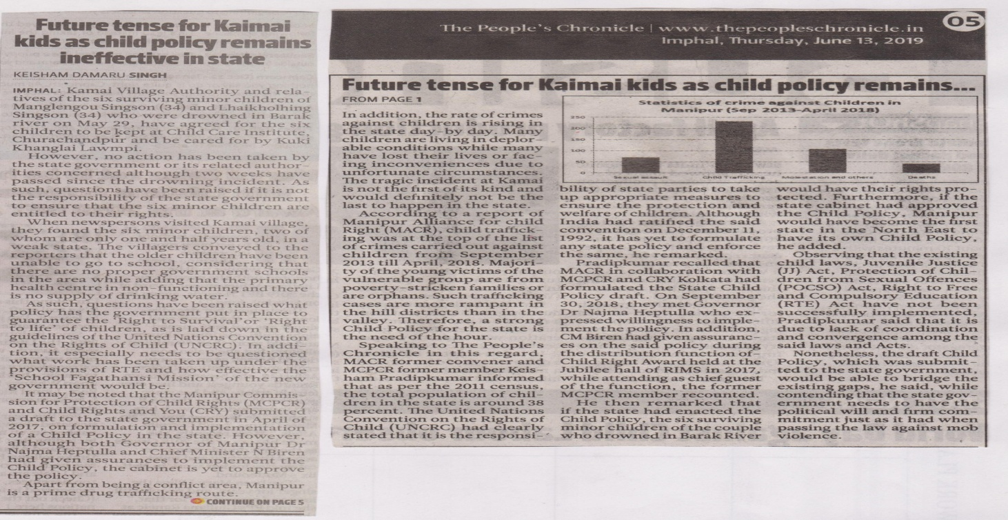
Paper publish by interns As a part of CRY-WIDE ANGLE Intern program, the student of Mass communication, Manipur University have written a report on the topics child sexual assault, Trafficking and VLCPC and other current child rights issues relating with the Child policy.

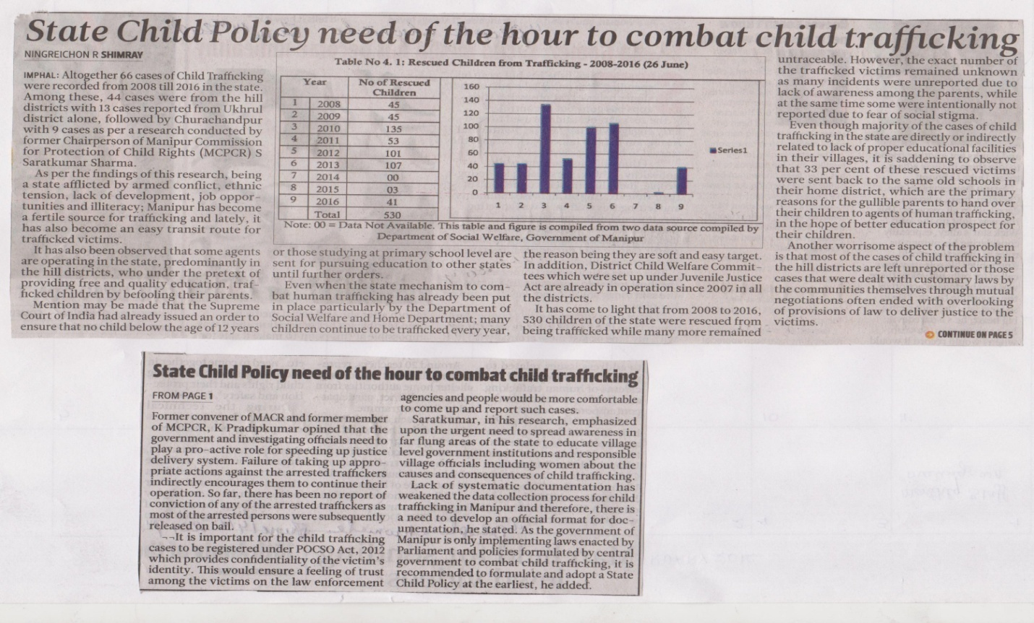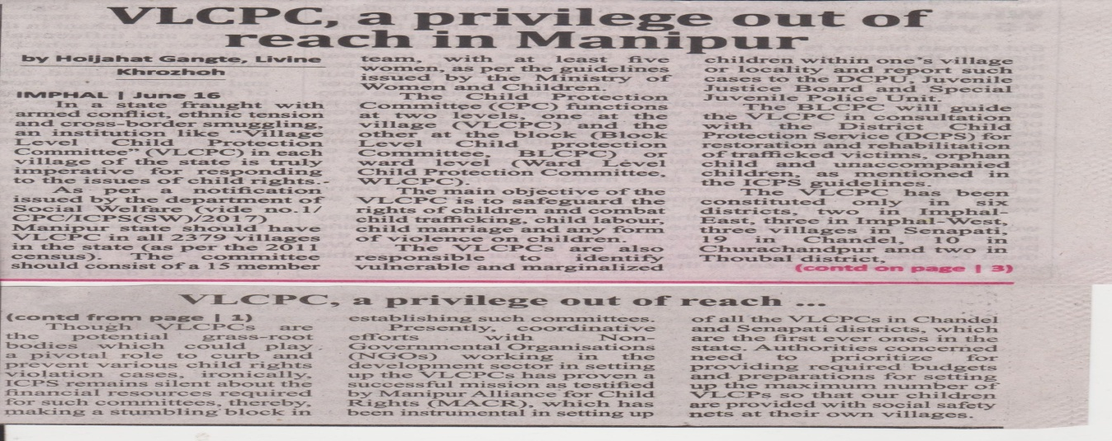
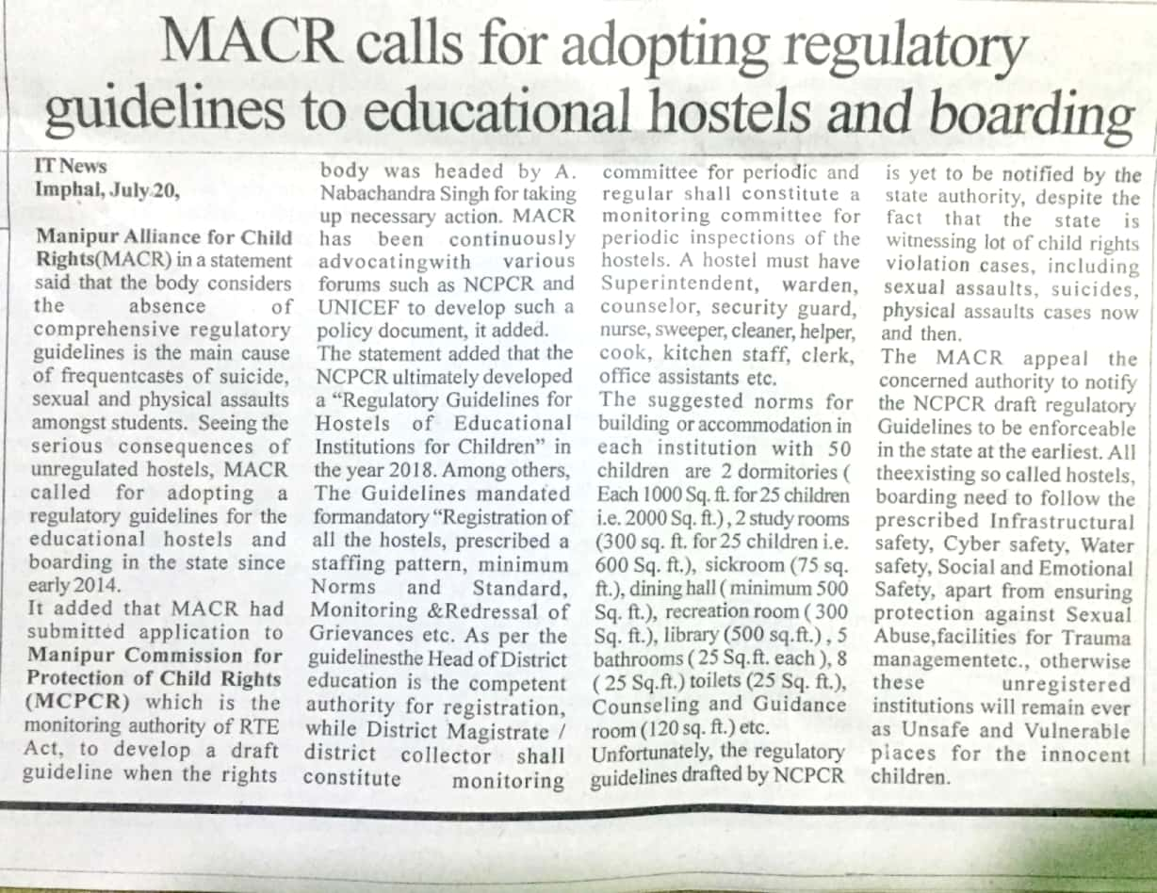
MEDIA PUBLISH
On 20th July a meeting was conducted in the Office of WIDE ANGLE discussing to take further steps to expedite the enforcement of the draft Regulatory Guidelines. Further a press release was made in the connection appealing the concerned authority to notify the NCPCR draft Regulatory Guidelines to be enforceable at the earliest in the state.
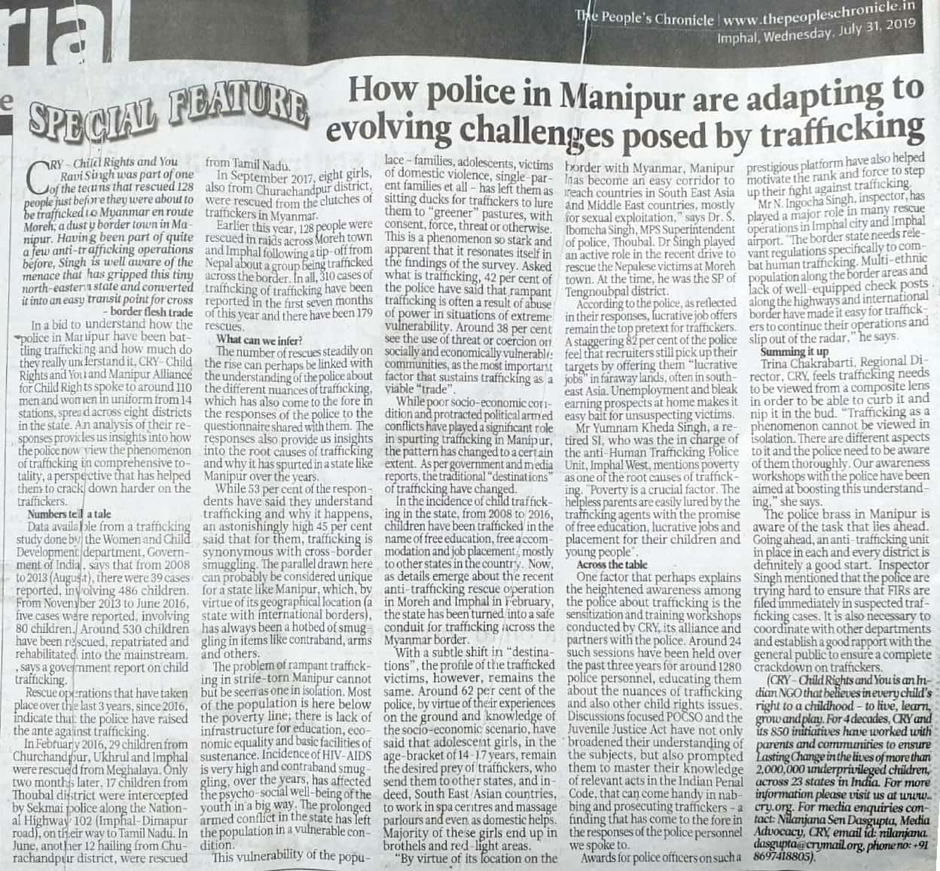
WIDE ANGLE released an article by CRY on 31st July 2019 at local newspaper on the topic:
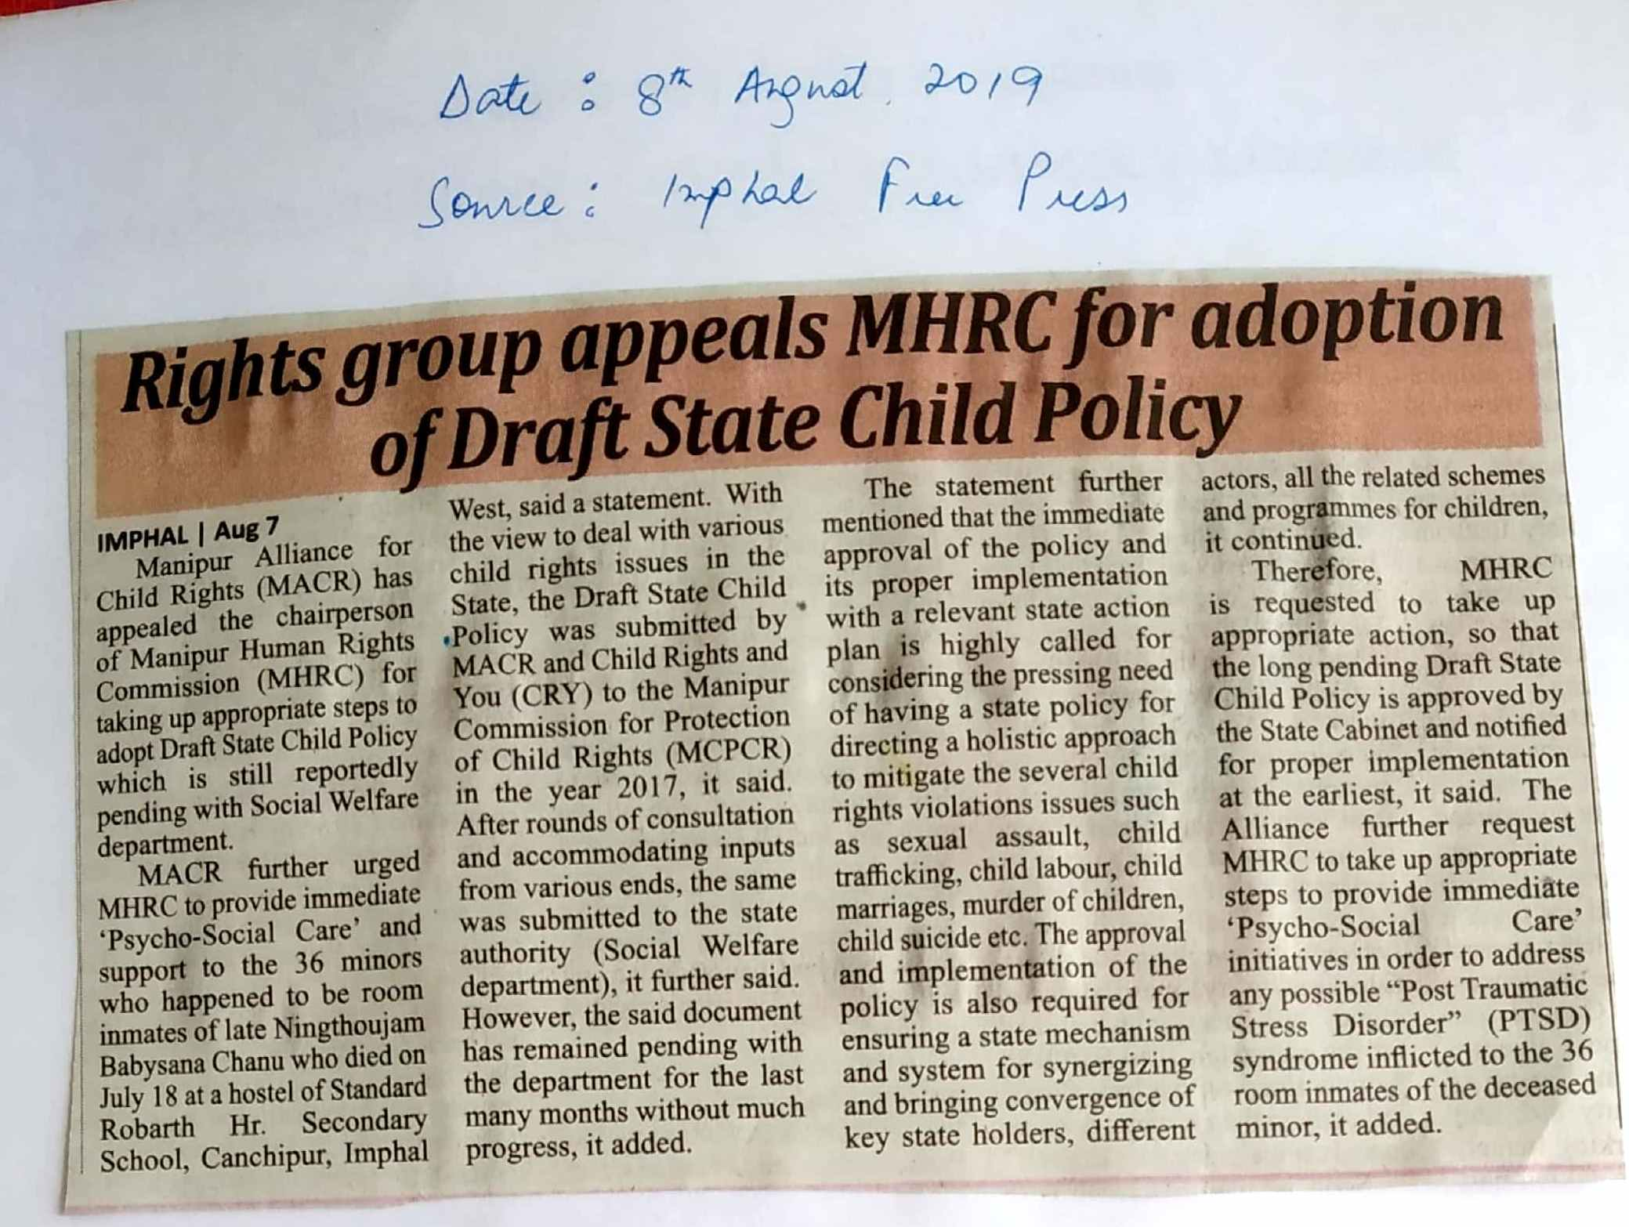
Sense and Sensibility- How the police in Manipur are adapting to the evolving challenges posed by trafficking.

AUGUST : A press release was also made in connection with rescue of three girls of Tengnoupal district of which 2 were minor from suspects leading to trafficking.

Press Conference
WIDE ANGLE and MACR conducted a Press Conference on 12th February, 2020 at Press Club, Imphal. in connection with

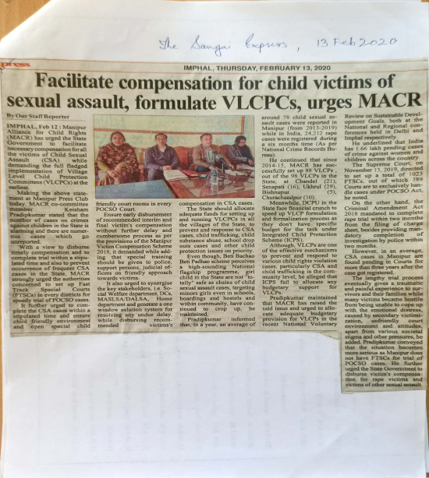
The children in Manipur are not totally “safe”, since chains of Child Sexual Assault (CSA) cases targeting the minor in schools, boarding and hostels, within community have continued to occur now and then. In an average, around 266 Child Sexual Assault (CSA) cases were reported in Manipur ( 2013 to 2019), while in India a total 24,212 rape cases were registered during a six months period i.e. between January 1, 2019, and June 30, 2019 (National Crime Records Bureau). Keeping the increasing magnitude of crime against children in mind, WIDE ANGLE is saddened to see some crucial existing gaps in the preventive approaches of CSA cases. One paramount example is the unhurried and seemingly unprogressive momentum on setting up of Village Level Child Protection Committees (VLCPCs) in all the notified villages of Manipur which is supposed to be implemented under ICPS, a flagship scheme. Since 2014-15 WIDE ANGLE has successfully setup some 88 VLCPs in the state i.e. Chandel (21), Senapati (16), Ukhrul (29), Bihsnupur (5), Churachandpur (10) out of total 98 VLCPs in the State. DCPU in the state face financial crunch to speed up VLCPC formulation and formalization process, as they don’t have specific budget for the task under ICPS. Though, VLCPs are one of the effective mechanisms to prevent and response to various child rights violation cases particularly CSA and child trafficking in community level, the irony is, ICPS do not allocate any budgetary support for VLCPs. WIDE ANGLE raised the said issue and urged to allocate adequate budgetary provision for VLCPs in recent National Voluntary Review (NVR) on Sustainable Development Goals (UNSDG) both in National and Regional Conferences held in New Delhi and Imphal respectively. The conference was also focused on: Issue of delayed Compensation and Lengthy Trial
WIDE ANGLE with MACR strongly urged upon the concerned state authorities for the following in order to disburse the compensation timely, to complete the trial within a stipulated time, and to prevent occurrence of frequent CSA cases in the state
- Setup Fast Track Special Courts in every district for speedy trial of POCSO Cases.
- Complete the CSA cases within a stipulated time as mandated by the related Laws.
- Ensure child friendly environment and open special child friendly court rooms in every POCSO Court.
- Ensure early disbursal of recommended interim and final victim’s compensation without further delay and cumbersome process as per the provisions of the Manipur Victim Compensation Scheme, 2018.
- Give special training to the Police, Support Persons, Judicial Officers on victim friendly approaches and to ensure speedy trail of Sexual Assault Cases.
- Synergize the key stakeholders i.e. Social Welfare Department, Deputy Commissioners, MSLSA/ DALSA, Home Department and generate a One Window solution system for resolving any undue delay, while disbursing recommended Victims’ Compensation in CSA cases.
- The State should allocate adequate funds for setting up and running Village Level Child Protection Committees (VLCPCs) in all the villages of the state, to prevent and response to Child Sexual Assault Cases, Child Trafficking, Child Substance Abuse, School drop-out cases and other child protection issues on priority.
Preparation of WIDE ANGLE poster
WIDE ANGLE have prepared two posters in order to spread out the message of child rights in Manipur. The first poster was on POCSO act and other was on Rights of the children. The said poster will be used during the mass campaign on school and other activities which WIDE ANGLE will undertake.

BREAK THE SILENCE CAMPAIGN
Break the silence campaign for Keibi High School, Imphal East was held on 16th April 2019 with the collaboration with Child Line Imphal East. During the campaign Somaj Sharma, State Coordinator describe the importance of doing this campaign and shared about the no of student cover up so far and also shared about the Dos and Don’ts of POCSO Act. Resource person Kiran, Center Coordinator, Child Line shared about the role and responsibilities of Child Line, POCSO Act and also describe about some cases which they have taken up. He further highlighted the consequences of early marriages as it may lets to POCSO cases and give some example about it which they have taken up. During the campaign a short film Komal and Like sister were shown which is produced by Child Line. All together about 250 student and teachers were participate in the campaign.
In Churachandpur the Break the Silence campaign were conducted at Sagang Hr. Sec School (280 Student and Teachers), Bunglon High School (160 Student and Teachers) and S, Kotland JV. School(130 Student and Teachers) with the collaboration with Child Line, CCpur. In Thoubal the campaign was organise at JNV, Umathel (430 student and teachers) with the collaboration with Child Line, Thoubal. In Senapati the campaign were conducted at Grace English School, Khabong Karong (310 students and teachers) with the collaboration with Child Line Senapati and Bathel English School, Kangpokpi (165 Students and teachers) In Bishnupur the campaign were conducted at The Pakhangba English School (130 Student and teachers), AIMS English School, Ishok (530 Student and Teachers), Brighter Academy, Nambol (300 Students and Teachers). In Chandel the campaign was organise at Shalom English Academy (105 Student and teachers) At Ukhrul the campaign was organise at KTL Excel Hr. Sec School on 3rd April 2019 (416 students). In Imphal West the campaign was organised at Brilliance School, Imphal West (160 Students). During the campaign WIDE ANGLE district partners shared about the purpose of Break the silence and shared about the scenario of child sexual assault which WIDE ANGLE have recently survey, about Child Line, POCSO Act and dos and don’ts on child sexual assault. 1960 student and teacher where sensitise on “Break the Silence” in the month of April,2019. All together 4698 were given awareness on Break the silence on this current year.
Break the silence (May)
WIDE ANGLE had conducted a school awareness campaign in CCpur at Bunglon High School (160),Kotland JV. School (130), Imphal East at Lamjingba Meira Sindam Sang, Phoudaibi (160), Chandel at KGBV and Toupokpi High School (297), Bishnupur at St. John English High school 410), Special Regular Higher secondary school ( 260),Special Regular High School (885) ,Imphal west at Brilliance School, Imphal West (160 Students) and Ukhrul at St, George School(100). During the campaign a poster on POCSO and Rights of the children were distributed and a film on child sexual assault were screened, power point on dos and don’ts and POSCO were also shown to children. Most of the campaigns were conducted with the collaboration with ChildLine.
Sl.No. | School Name | Districts | Nos. of Students
1 | Bunglon High School | CCpur | 160
2 | Kotland JV. School | CCpur | 130
3 | Lamjingba Meira Sindam Sang, Phoudaibi | Imphal East | 160
4 | KGBV& Toupokpi High School | Chandel | 297
5 | St. John English High school | Bishnupur | 410
6 | Special Regular Higher secondary school | Bishnupur | 260
7 | Special Regular High School | Bishnupur | 885
8 | Brilliance School, Imphal West | Imphal west | 160
9 | St, George School | Ukhrul | 100
10 | JNV, Umathel | Thoubal | 500
11 | KM Blooming School, Khangabok | Thoubal | 510
 | Total Nos. of Student covered |  | 3572

Break the Silence Campaign
In continuation of Break the Silence Campaign, on 19th of July 2019 a campaign was conducted at Yurembam Junior High School, Imphal West. A total of 41 students were present during the program. KOMAL video was screened and answers were given to the assessment questions for understanding the CSA by the students.
Break the Silence Campaign
A Three days Inter State Child Rights Awareness programme was organized from 21 Nov to 23 Nov 2019 in collaboration with WIDE ANGLE, Child Line Senapati and Child Line Peren, Nagaland covering about six villages, schools and hostels. The programme focused on Child sexual abuse, child labour, abused/ violence, child trafficking, missing, orphan and homeless and provisions in accordance with JJ Act and POCSO.
Break the Silence Campaign
As continuation of Break the Silence Campaign, on 13th December 2019 a mass awareness campaign was organized at Tabitha Children Home, an orphan home at Mantripukhri Raphei Valley. The children belong to vulnerable and destitute families who are infected and affected by HIV AIDS. Altogether 32 children were there, the youngest among them being in class Kg and others range till X Standard. The children were made aware of good and bad touch, the KOMAL video was screened and answers were given to the assessment questions for understanding the child sexual assault by the children. The staffs of the home were very cooperative and showed their gratitude for organizing such programme.
WIDE ANGLE guidance and support to a child : On 20th June 2019, Anand Sharma of Uripok has contacted WIDE ANGLE State coordinator on the issues of a guardian of a child trying to sell of his property. The name of the child is Laishram Nikesh Singh aged about 14 years, who is an orphan and his uncle who is said to be the caretaker is L. Birkumar Singh. As the child is a minor the property of the said child was given to his uncle Birkumar. Now the uncle is trying to sell of his .32 Acre of land by forcing the child.
This came to the light of one teacher at SAI who in turn inform Anand Sharma. WIDE ANGLE contacted Rajkishore, Child Welfare Committee, Imphal West and he inform us to write an application to CWC seeking to ban all formed of selling the said property. He also further inform us that as the child is minor they can’t sell of the land but still we can’t take risk so he told to write an application and the CWC will instruct the concern DC to look into the matter.

Sexual Assault Case at Manipur Public School, Koirengei : Former WIDE ANGLE coordinator contacted WIDE ANGLE that a sexual assault case has been reported from Manipur Public School, Koirengei on 26th of October 2019. Accordingly the Childline Imphal East was contacted right after the news so as to act in the case. A girl of VI Std., Sneha, aged 13 years had stayed back in her classroom alone with permission from her class teacher during the morning Assembly hour as she was feeling sick. Sneha’s account is that two mask person one in civil dress wearing red T-shirt and another in school uniform came to her and dragged her towards the wash room which is almost opposite her classroom but before they could undo with her shirt, the assembly dispersal drum began and so the two person ran away jumping out of the window towards the fields adjacent to the school. The Childline and the in-charge of Child Friendly Police came and examined the place however, evidence failed to prove of any such occurrence of the incident. The girl came from disturbing parents who were living separately and was irregular to school. It is felt that the girl might be mentally stressed and having hallucination. However, for any further step in the case, her parents are not at all cooperating. The case is being close from the side of the Child Line and the Police.
POCSO Case : A case of POCSO came to the WIDE ANGLE, a minor girl child of age 6 years, reading in Class KG was sexually assaulted by another minor of age 15 years as per academic record in the Imphal East District. The girl child was staying at her aunt’s place as her mother being a divorcee and struggling to meet days end could not look after two children, thinking it safer she had kept her minor daughter with her sister. The boy is from the same n9eighborhood and very close relative. The incident started to happen since October 2019. A Women group, contacted WIDE ANGLE and a complaint has been made on 29th November at Women Police Station Imphal East and necessary medical examination has been done. The girl belongs to Thoubal District and accordingly WIDE ANGLE Thoubal partner has also been informed. On 30th December, the JJB Imphal East has rejected the bail to the child in conflict with law.
The mother of 6 year old girl, victim of POCSO case after knowing that the JJB Imphal East has granted bail to the child in conflict with on 22nd January, has been undergoing psychological counseling and that she had been calling the WIDE ANGLE team seeking advice. She was given proper counseling that it is the right of the CCL to get the bail and also it is not the end of the case.
A POCSO case of 2015, Imphal West got conviction in November 2019, as per the recommendation of the Court for providing compensation, the victim party approach WIDE ANGLE regarding the process. They were advice to make a reminding Application to MASALSA. This reminder letter to MASALSA surfaces the shortcoming in the process of Manipur Victims Compensation Scheme that necessitated a meeting with the Secretary of MASALSA.
Eloping case : In a case the Parents of a minor girl child of age 16 years came to office of WIDE ANGLE seeking guidance regarding eloping of their girl child with another minor boy of 17 years old. They were given the knowledge of child marriage and also brief of POCSO Act and advise to amicably deal with boy’s parents with the same. They were also advice to deal the children sensitively so as not to repeat the same.
Yet in another POCSO case in which a 13 year old child is alleged victim of repeated aggravated penetrative sexual assault committed by accused since 2014. The offence came to light when the child was taken to RIMS hospital for treatment related with Gynecological problem, and accordingly on 16th March 2020 FIR was filed. Though the child was restored to her parents, the parents informed CWC Imphal West that the child is not safe at their home and it will be in her best interest if she can be given shelter in a children home for some period. The girl is given temporary shelter at Nirvana Open Shelter for Girls, Ghari. For the said case the State Coordinator had no choice but to be the support person of the case as there were none willing to be so.
In another case of POCSO from Patsoi part III, the parents of the victim contacted WIDE ANGLE office for consultation as to the case that during shifting of their residence from one to another they have misplaced or lost the documents of the case however, the father had a photocopy of an affidavit that was endorsed for receiving interim compensation. The parents were advised to contact the CWC Imphal West and to update with the case from the Women Police Station Imphal West following through the FIR no.
CHILDREN RESCUED
On Rescue Operation of Three Minor Girls from Tengnouple District

On 3rd August, our Chandel correspondence informed that 3 girls ( Neelam age 19 years, her younger sister Pooja, 16 years and Afsana 16 years ) from Moreh town were missing since early morning from their houses. After confirmation, a Missing Report was made by the parents of the two siblings at Moreh Police station with the help of our WIDE ANGLE Candel Correspondence and an alert was sounded and a special task force was formed which immediately contacted the OC Imphal West, OC Khongjom and SP Thoubal. An alert was made with the Anti Human Trafficking Unit stationed at the Airport. A Missing Report was made by the parents of the two siblings at Moreh Police station at 10:30 AM with the help of our members. One of the constable at Moreh check post informed that they had seen the girls heading for Imphal, OC Khongjom Kh. Dilip and SP Dr. Ibomcha of Thoubal Police were also alerted so that they could intercept the girls on the way.
OC Imphal West Shri Ingocha informed that around 12:30 PM one of the girls were rescued from the booking counter at the airport by the team effort of SDPO Romendro under the supervision of SP Imphal West, CISF, the Commandos and the Airline Staffs and the other two from North AOC Bus ticket counter. They were then handed over to Special Juvenile Police Unit of Singjamei Police Station and kept at Child Friendly Police Station Lamphel under the supervision of Imphal West SP Shri Meghachandra.

Out of the three recued girls, Neelam was planning to go to Delhi as someone whom she befriended through Facebook had offered her in getting auditions for TV Serials. Pooja, the younger sister of Neelam who too wanted to follow her sister to work in the TV serial along with her friend Afsana who was married at such a young age of 16 years too did not want to stay with her husband who was very senior than her co-planned to follow Neelam.

The two minor girls planned to go by bus till Dimapur (Nagaland) and take the train for Delhi and contact Neelam who was going by flight hoping to meet as soon as they reach Delhi. They had no idea what and where they were going to lend up except for the good hope.

The children were heard by our staffs and Childline Thoubal of the reason of taking such a step and also their desire thereafter. The eldest of them was a matriculation failed for third consecutive times n pooja too Matriculation failed and Afsana got Compartmental in one subject in matriculation. In the whole of case, the children had express their desire not to return home and be accommodated in a place where they can pursue for a better future.

In the evening around 7 pm they were released and handed over to Moreh Police personals, accompanied by the parents of Neelam and Pooja and the husband and mother of Afsana who had also come down to Imphal. The girls were later accommodated at the Ujjuala / Shelter Home, Moreh and processed to be produced at Child Welfare Committee, Chandel, after the hearing, the CWC passed an order and handed over the children to the respective families.

WIDE ANGLE is looking into two angles from this incidence, whether it is a simple case of runway from home for pursuing better economical future or is it a big racked of Cyber criminals trapping young girls on Social Media with false promise and exploiting their innocence. This need to be further investigated by the concern Police official handling the case so that other children would not be trapped in a similar way.

Missing Children Rescued : On 14th March 2 boys, both 17 years old, who were missing since 22 January 2020 from their School Boarding, Don Bosco School ,Maram, Senapati district were able to trace and rescued from Guwahati by Childline Senapati.
On 17th March a boy was rescued along with Childline Senapati from Maram Bazar, Mao, Senapati District, who was handed over to his uncle considering him as the fit person and proper counseling was provided by the team CWC and Childline Senapati.
Amidst the lockdown of COVID 19 pandemic, on 23rd March a 4 year old girl hailing from keibul, Moirang was rescued by our WIDE ANGLE Churachandpur coordinator who had been sold by her own father and grandfather in the absence of her mother. The child was rescued from Ningthoukhong, Bishnupur District, an FIR has been lodged against the culprits. The child has been produced before CWC and been restored at Naoyok Naothemkol, (SAA). Thamnapokpi, Bishnupur District on the same day.
MEDIA ADVOCACY
Participation at ISTV Program and interview by Imphal Free Press
Keisam Pradip kumar was invited to be a panelist member at IS TV Network on 25th April 2019, on the issues of present trained of Extra Marital affairs of parents and the effect to children. The panelist during the discussion was Professor W. Nabakumar, Manipur University and Dr. M. Binota, Chairperson, Manipur Women Commission. Pradip shared about the concern of safety of children.
On 27th April 2019, Imphal Free Press has taken an interview from Keisam Pradip on the issues of one child who claim to participate in the UN. During the interview he informs that if the news is fake, it will be a testimony of child abuse and cyber crime committed by parents to fulfill their vested interest as Face book policy does not permit anyone younger than 13 years of age to open an account and the child is only 7 years of age, and she being a child does not have the authority or the ability to post extended clarification on face book before registering a new account. He further shared that a post on social media in this issue have also criticize Karnajit for creating a fake account in her daughter’s name for his own perverse ends and maligning the image of his own daughter.
Interview by Times of Manipur (TOM TV)
An exclusive interview with Keisham Pradipkumar, Member MACR was taken by TOM TV on 21st of June 2019 at the residence of Keisham Pradipkumar, Wangkhei Ayangpali Road. The interviewer asked about the POCSO Act, present scenario of sexual abuse on child in the state, punishment under POCSO Act and about the status of State Child Policy.
Keisham Pradipkumar narrated about the features and punishment under POCSO Act, 2012. He further added the cases happen both in hill & valley region. Answering to the question of the causes of the child sexual abuse in the state, he react that Manipur being an armed conflict state tends to increase the risk of children lives and also the influence of Social Networking Site increases the nos. of cases in the past years. Some happens to fulfill their sexual arousal. At the end he reminded that WIDE ANGLE had drafted the Child Policy with the help of MACR and CRY, Kolkata and it was already submitted to the CM of Manipur but the cabinet hasn’t pass the bill yet and waiting for the policy to be put up at Cabinet.

Interview by Katmandu Times
Keisham Pradipkumar, member MACR has taken interview by Katmandu Times, a local daily newspaper of Nepal on Human Trafficking. He talked about the nature & causes of human trafficking, how to deal to with a trafficker, the present scenario of trafficking in India mainly in Manipur state as it becomes the transit route for human trafficking.
Interviewed by AIR, Imphal on the International Day against Child Labour
Keisham Pradipkumar gives a short comment on Child Labour during a function on the International Day against Child Labour. He suggests framing a Sate Child Policy as soon as possible to combat from such unwanted acts to the child. He further added that every child should have to enjoy their childhood in a decent way. Education should be given to them instead of forcing them to work.
Impact TV Discussion Hour : WIDE ANGLE Secretary Montu Ahanthem took part in a discussion on a local TV Network Impact TV as a panelist on an issue related to the moral punishing which involved a minor child. The increasing trend of incidents getting viral in social media especially where a minor is associated is a major concerned in the present social scenario, when a crime is committed by their guardians the impact faced by minors would stay for lifelong and therefore the minor needs to be properly counseled and rehabilitated so as to enable to cop up the incidents considering the future of the child. To curb occurrence of such incidents he opines that stringent mechanism should be taken up by the State Government and further in the same platform he urges the Manipur State Government to bring in the Act of the Manipur Protection from Mob Violence Bill 2018 at the earliest.
Panelist at ISTV Discussion Hour
MACR core member, Shri Keisham Pradipkumar was a panelist in a discussion at local TV network on the topic “Participation of School children in Agitations”. The discussion was in connection with the NCPCR taking up of a sou-moto cognizance concerning the using of school children at a protest rally which is a violation of Sec 75 of JJ Act, 2015. Based on a report published in regional news portal, the commission has taken suo moto cognizance of the matter under Sec13(1)(j) of CPCR Act, concerning the usage of school children in public procession, political rallies etc. The Commission had sought a report of the action taken within 15 days from the SP Imphal West.
Media Panelist : During the second quarter MACR State Convenor and Sec Wide Angle Mr. Montu Ahanthem and Mr. Keisham Pradipkumar were in Media Panel Discussion in various topics and media platforms respectively.
Right to participation : Shri Keisham Pradipkumar was a panelist on discussion “Right to participation” at launching of YouTube News Channel Meeyamgi Khollao (People’s Voice) by Imphal times on 9th February 2020. The discussion is focused on the comments of freedom of expression and the misinterpretation of the expression of the term Right to Participation of children arising from various quarters vis-à-vis CRC, UNICEF, JJ Act etc.
Importance of State Child Policy on Agenda Manipur
Importance of State Child Policy on Agenda Manipur by Impact TV on 23rd February Shri Keisham Pradip stress on that the draft policy was submitted in the year 2017 and till now it is yet to be brought out in spite of assurance given by the Chief Minister and Governor of the State in the year 2017 and 2018 respectively. The Policy needs to be implemented holistically in the best interest of the children of the State which is framed keeping the scenario of the needs of the State.
WIDE ANGLE Sec and MACR State Convenor, Mr Montu Ahanthem reiterated the accounts that after submission of the Draft Policy feedbacks from all the concerned departments were open and responded too accordingly for instance, the Social welfare Department, the Labour Department, and the Home Department. The National Commission for Protection of Child Rights also has recommended that such Policy be brought into action. All the necessary procedure has been accomplished then. Taking advantage of the media Platform the seniors of the WIDE ANGLE made an earnest appeal to the State Government to act in the best interest of the well being of the children of the State and help mitigate the wanting in the mechanisms as well as in the convergence among the stakeholders.
MEETING WITH STAKEHOLDERS
Meeting with the Proprietors of A2Z
As per the instruction from Ashim Gosh, Associate General Manager, CRY, WIDE ANGLE staff went to see the status of donation box which has been installed at Nine Hills Bistro and send the photo to Ashim. He informs us to look for another place as there is no such improvement in the donation box. So we have taken an appointment and went to meet the proprietor of A2Z, Donel at 2.30.P.M.on 9th May 2019. We brief about the purpose of visit to his restaurant and described about the worked which we have taken up and the amount we collected from this will be used to support the marginalize children of Manipur. So we requested him to put the donation box in his restaurant and he also accepted our request.
Meeting with official of MCPCR
WIDE ANGLE staff went to meet the Chairperson of MCPCR in order to follow up for Child Policy and regulation and monitoring of private run children home on 9th May 2019. The staff informs us that the Chairperson was not at office and will be late, so we met Samuel, Program Officer and interacted with regarding the status. As for Private run boarding and hostel he informed that they had already plan to have a meeting at the office chamber of Hon’ble Social Welfare Minister with the concern Principal Secretary but the date has not been given by the office of the Minister. For the Child Policy the information WIDE ANGLE have is same with what he told us.
A short interaction with Officer in Charge, women police station, Porompat
A short interaction with Gurumayum Gitanjali, Officer in Charge, Women Police Station, Porompat were held on 14th May 2019 with WIDE ANGLE members headed by Keisam Pradip. During the interaction we discuss issues related with POCSO and the various steps taken up by police and the problem faced by police. At the end of the secession Pradip requested the Gitanjali to set up a child friendly police station as there is also an order from the court. The officers in charge inform that the she is ready to set up the child friendly police station after discussion with their senior officers as it will helps for the children to fell homely at their station.
Meeting with SP of Thoubal Districts on Child Friendly Police Station
On 20th of May 2019, WIDE ANGLE Staff met with the SP of Thoubal Districts and discuss about the opening of Child Friendly Police Station. He assured to open the unit by end of the month but couldn’t undergo the process as currently there is chaos in the police station about the rumors of transferring the SP and other staffs.
Interaction with DCPU, Tamenglong & CWC, Churchandpur
On 10th June 2019, WIDE ANGLE had a telephonic interaction with Lunganglun Cheibong Phaomei, Program Officer, DCPU Tamenglong and Florence, Member CWC, Churchandpur on the issues of an unfortunate incidents that both parents were drowned in Barak River at Tamenglong which led to the orphan of 6 children from Tamenglong. WIDE ANGLE was approach by media that those children who became orphan were never contacted by the social welfare department and other related stakeholders. We listened to the question upraised by the media and told them that we will hear from both the sides and will contact them in this regard. We contacted the DCPU, Tamenglong and inquired about the status of the 6 children. They informed us that they’ve already visited twice and discuss with one of the guardian and social worker, and the process to transfer the children from Tamenglong to Churchandpur is already done and the final paper will be over by 3pm of June 10. Also CWC, Churachandpur have already given consent to put all the children together in a children home run by Kuki Women Union.
Then we contacted Florence, Chairpersn CWC, Churachandpur and enquired on the issues of the 6 children. She informs us that the children will be handover today i.e 10th June 2019 by DCPU, Tamenglong and inform that they’re already on the way. She also told us that the paperwork for hand overing the children to Sangga Muon in an Orphanage run by Kuki Women Union will be done. She further shared that the civil society organization had requested her to keep all the children together in a home so they’ve decided to keep the Children together.
Meeting with Chairperson of Manipur Human Rights Commission
Keisham Pradipkumar met with the Chairperson of Manipur Human Rights Commission Shri Khaidem Mani as a follow up meeting of the memorandum submitted to the MHRC on the status of the Child policy. As per the responses from the Social Welfare Department, it was mentioned that the policy has submitted to other line department and it still needs to be produced in the Cabinet Meeting. WIDE ANGLE requested the MHRC to take actions so as to implement the policy as soon as possible. Shri Khaidem Mani also assures to take further necessary actions to enact the policy as sooner as possible.
Meeting with DCPU, Imphal East and Imphal West : WIDE ANGLE team met with the DCPO Imphal East on status of Village Child Protection Committee,. The DCPO told about the challenges in forming the VCPC and making it functional in Imphal East District. She also stated that they have been discussing of forming a model VCPC in village under IE district and that they have formed 2 VCPC so far.
The status of Imphal West is almost same with that of Imphal East, there is 3 VCPC and more on process with the Social Welfare Department. The DCPO also spoke on the challenges of making it functional. The DCPO urge to collaborate with WIDE ANGLE in the formation of the VCPC.
Meeting with Stakeholders on status of Child related issues
The WIDE ANGLE team has been visiting various stakeholders seeking details on nature, frequency of cases related with children. The Officer in Charge of Imphal East expressed that due to lack of manpower and improper infrastructure they face a lot of problem. From the Child Protection Officer of Bishnupur district the drugs and substance abuse cases are on a hike with children. The team has been visiting newly established Child Friendly Police Station on the functioning of the station and this shall be covered by next month. The team has been updating with the number of POCSO cases for the year 2019 for Imphal East and Imphal West District respectively.
Meeting with Stakeholders : Senapati Child Friendly Police Station
A visit was met at the Senapati Child Friendly Police Station and had an interaction with the Welfare Officers on the 2nd week of January 2020. The meeting was focused to track the status and nature of cases dealt by them especially after the inception of Child Friendly Police Station. The police officials expressed that the villages being in the interiors of the hill district often cases are reported late and also that the officials faces difficulty in attaining them immediately due to the location, lack of manpower and also the vehicle. The WIDE ANGLE team also felt that the officials need to be capacitated in the proceedings as to deal with cases related with Children.
The WIDE ANGLE Coordinator also met with the Asst. Secretary of MASALSA regarding the process Manipur Victims Compensation Scheme over which the Asst. Secretary expressed disappointment with the Home Department as the provisions of the Scheme is not followed in practice.
Meeting with newly appointed CWC, JJB members.
The meeting with the newly appointed members of JJB, CWC has been started by the senior members of WIDE ANGLE during the month of February 2020.
Meeting with Cabinet Ministers
As a part of legislative advocacy and lobby, the MACR Executive Member, Mr.Keisham Pradipkumar met the opposition Minister of Legislative Assembly Shri Kh. Joykishan giving relevant documents to move a calling attention motion in the ongoing Assembly. However, the opposition MLAs took a walk out protest on the last day of the session and therefore, the matter could not be raised, though MLA Ms Mk. Mirabai raised a broader issue of sexual assault cases against Women and children.
Mr Keisham Pradipkumar, Executive Member MACR on Social media post addressing the Hon’ble Legislatures that a draft Manipur State Child Policy remains pending for the last 3 years with the Government and to discuss the matter on the ongoing Assembly session.

ONE DAY CONSULTATIVE MEETING ON VILLAGE CHILD PROTECTION COMMITTEE UNDER ICPS:

Moderator: Mr. Wungreiso Shangh, Project Officer, FXB, Ukhrul
Resource person:
- Mr. Pabitra Thingbaijam, DCPO, Ukhrul.
- Mr. K. Pradeep, WIDE ANGLE
- Mr. Raj Kishore, Chairperson, CWC Imphal West.
Recording secretary: Shonrei Zingkhai, co-ordinator PASDO - CR.

One day consultative meeting on Village Child Protection Committee under ICPS was organized on 13th May 2019 at Phila Foods Training Centre, PASDO Office Complex, Dungrei, Ukhrul.
The meeting was attended by 32 members including representatives from various NGOs operating in the district, SMDC, MACR,WIDE ANGLE, CWC and DCPU. The program started at 10:30 am.
Gajendra Prasad Mohanty, Convener UDACR addressed the gathering with a short welcome speech and highlight the gist of the program followed by a round of introduction by the members present in the meeting.
Mr. Pabitra Thingbaijam, DCPO, shared the important of setting up of Village Level Committee in order to tackle violation of child right in the villages. In Ukhrul district, NGOs play a vital role in helping and controlling the issue to a great extent. He also shared the challenges in setting up of such committee in the village. He urged all the stakeholders to kindly co-operate and support each other as the issues is the concern for all the stakeholders.
Mr. K. Pradeep, MACR, shared the structure, roles and responsibilities of VLCPC (Village Level Child Protection Committee). He opined that each and every village should have such committee in order to reduce the vulnerability of every child.
Mr. Raj Kishore Chairperson, CWC, Imphal West and Advocate High Court, Manipur, took the technical session. He shared on the legal provision of a child protection under JJ Act. He asserted that we need to know the legal provision as every one of us is responsible for the wellbeing of a child.
Discussion/Outcome:
The participants thoroughly discussed the pros and cons and the challenges while forming VLCPC in the villages. After the thorough discussion the members present unanimously agreed to go ahead for formation of VLCPC with the corporation and support from DCPO:
- DCPO to endorse FXB and PASDO for the formation of VLCPC.
- To complete formation of 50 VLCPC by the end of the year i.e. 2019 (30 by FXB & 20 by PASDO).

Formation of VCPC
Three Village Child Protection Committee at New Keithelmanbi, Namching Mahakabui and Lonjang of Kangpokpi District has been formed and the same has been forwarded for the formulation at DCPU Senapati, there is no DCPU as yet for the newly formed Kangpokpi district.
Hill District Consultation on POCSO/JJ Act and customary practices in collaboration with DALSA ( Chandel District)
A one day consultation on POCSO/JJ Act and customary practices for Chandel district was done on 31st May 2019. About 72 community leaders and govt. stake holders where participated in the said program.
Resource person at one day training program for police personal : Keisam pradip were invited to be a resource person for police personal organise by police department. Prdaip Keisam topics were on the issues of child rights and juvenile Justice Act. After the program Pradip discuss with Ms Amrita Sinha, Superintendent of Police, Chandel about setting up of child friendly police station he further inform that WIDE ANGLE is ready to provide the support and resource person for training the police in setting up the said station. The SP also takes keen interest in setting up of Child Friendly police station and informs that she will comply to it as soon as possible.
Report of the One Day Consultative Meeting on POCSO Act and Customary Laws, Ukhrul
Sir Gajendra gave the welcome address to all the participants and to resource persons as well. In his key note, he emphasized on the purpose of consultative meeting. He said the purpose was mainly to discuss on two laws namely:
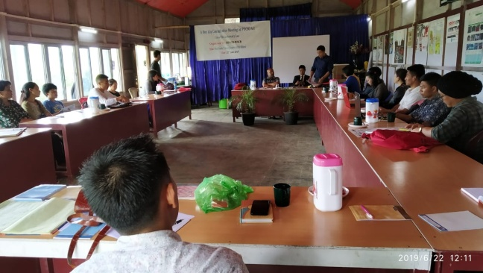
- POCSO Law and
- Customary Law
He told the participants that these are the themes of how to go on and create a safer environment for our children in our Tangkhul’s Community. Our community had their own customary law depending on their villages. So, we need to come out with the concrete idea from each and every persons present here.
Summary (On POCSO Act 2012) Mr. Sira Kharay
Mr. Sira says that this POCSO Act was not made by the constitution of India but it was from the UNO (United Nation Organization) to protect the right of child from below 18years. Under the article 1, Convention suggests to protect the right from the trafficking, pornography and rape.
As the world becomes more modernized day by day, the definition of rape does not only suggest the act of forcing sexual intercourse to a child but it is much more than that. POCSO Law has been widely expanded. Even staring at a child private part is also violated the law. The person can be put under the case according to the POCSO Law.
As an example, in case less than 18 years of both boy and girl got married and if anyone of the family lodges a complaint, person can be put to a jail. The punishment of rape case is more heavier and heavier, even of the sexual assault will be 7 to 8 years in jail.
According to POCSO Law no one can be neglected. Police have to record the compliant, parents have to compliant it if they know that their child had been rape/ sexually abuse , even the Dr. have to make complain if they know that the child had been rape through the medical checkup, if not they will be in jail due to their negligent.
When we complain to the police because of this reason they need to give the information within 24 hours to the CWC. POCSO Law is both for the boys and girls. In our community we do not have the idea of POCSO Law. So we have lots of loopholes on this matter. In this regard NGO’s can take part in enforcing this law.
We can never share the identity (like home address, school, locality, village, etc) of a victim person either directly or indirectly. Even in electronic (like face book, what’s up, messenger) it is strictly prohibited.
When a child is rape and is a female and brought to a hospital for a medical checkup a victim should be treated by a female Dr. Police should not interrogate the victim with the uniform but should wear the casual dress. They should not interrogate the victim at police station but should be in the victim house or wherever the child prefers. The interrogation should be with the present of the child parents.
POCSO Law is contradicting to the customary law. So, even the Kerela High Court also emphasized on this because sometimes the parents made a child marriage who is under 18 and when they are not happy with their in-law they filed a complaint that it is rape under the POCSO Law.
Court is just implementing the law but it is the legislation that makes a law.
Summary from Mr. Somaya Mungrei (Customary Law Vis-à-vis POCSO Act 2012)
Customary law did not have a proper rules and regulation. We thought it will not happen in our place but it is happening in our place too. Till date we have 11 cases based on POCSO Law. In our case we have hidden so many cases base on rape and molestation by the family members and even by the Longnao (Union).
No excuses in POCSO Law. POCSO Law overtakes the Customary Law. We can’t implement the law better than this law.
Suggestion/or main focus:
- Take more important on child.
- How this thing will not happen?
According to France law if the boy rape a girl and if the boy says that he will marry to this particular girl a case will take out from him. In our customary law, if the boy rapes a girl and if he wants to marry her, he can marry that girl.
This case can be happened mainly by the relatives, neighbors, and the person who know the child well. A victim can be taken to the psychiatrist/psychologist for mental help and can be treated in one house until and unless he/ she is recovered from trauma.
We can spread more ideas on this and let the people know more on this area. We have properly implemented on POCSO Law in Ukhrul. We can’t compromise on this but we need to move forward.
Recommendation from Participants
- Awareness campaign with the Longnao (different union) and advocate as a consultative Meeting/Programme or Campaign in the future.
- We need to see how the counselor can intervened on this matter.
- Compromised should not be done on POCSO Law with the Customary Law.
- Rehabilitation should be provided to a child.
- NGO’s also needed to take responsibilities and take it as a very important matter.
- Two juvenile child marriages should not be put into a case.
- More sensitization programme is required to give awareness to societies.
- To be more effective apex body (Longnao) and NGO’s needed to work together than only the positive result will come in our society.

Child Friendly Police Station
After the convergence meeting held on 27th June 2019 with the Superintendent of Police, M. Pradip, the concern S.P had order vide No.C/SP-SPT/19/3/98/ had appointed Child friendly police officers for Mao, Tadubi, Senapati and Senapati Women Police station.
Kakching Police also opened up a child friendly police station after a series of meeting by Thoubal, MACR chapter and child line Thoubal.
Bishnupur police had also opened up a child friendly police Station on 28th June 2019 after the consultation on 11th June 2019 held at the hall of SP.
Capacity Building Programme for proper implementation of Child Friendly Police Station
A one-day Capacity Building Programme for proper implementation of Child Friendly Police Station was held on 28th July at SP Conference Hall, Churchandpur Police Station. About 37 police personnel were present during the Programme. The police were sensitized on how to deal with a child case. The Do’s and don’ts while investigating a child case were also discussed.
Training of RAMSA & SSA on RTE & Child Protection
A training program on RTE & Child Rights to protection was organized by Department of Social Welfare on 16th of July 7 17th of July. The program was held at City Convention, Imphal. During the program Pradip Keisham speak about the Right to Education. He also elaborates about the Child Protection Schemes.
Awareness Programme on Drug Abuse and Trafficking : A One Day Awareness Programme on Drug Abuse and Trafficking were organized jointly with Wide Angel, Patsoi PS & MACR. During the programme MACR Convener and Secretary Wide Angle Shri Montu Ahanthem talked about the current trends of increasing numbers of drug use by children (14-18 yrs.) which lead to exploitation of their right to life. He also highlighted the works carried out by WIDE ANGLE on child right issues. OC of Patsoi PS, Shri Dhanabir Laishram Social Scientist, Former Chairperson MCPCR Shri S. Sharat Sharma and President of Local Club attended the program.
Attending World Day against Human Trafficking Day at SP Thoubal Police Station
World Day against Human Trafficking Day was observed on 30th July 2019 at the office of SP Thoubal Police Station. The program was organized by Child Line Thoubal & Thoubal Police. Keisham Pradipkumar, member MACR attend the program and took a session on VLCPC. He talked about the formation of VLCPC and why we need to form the VLCPC in order to protect and care our child. VLCPC will help to fight against the child from trafficking and will let them to educate and growth in a proper way he added.
District level consultation on VCPC under the guidance of ICPS on CSA
A one-day district level consultation on VCPC was held at Torbung, Churchandpur on 30th July 2019. About 30 participants attend the Programme. Rebika, WIDE ANGLE correspondence talked about the issues on Child Sexual Assault, Child Trafficking. She also speaks about the VCPC.
One day District Level Multi Stakeholder Convergence Meeting/workshop on ensuring Child Protection in the Senapati district
We have organized a one day district Level Multi Stakeholder Convergence Meeting/workshop on ensuring Child Protection in the Senapati district at the DRDA Hall, Old DC office at Senapati district. In the program, Mr. Lalminlen Mishao MPS - Addl. SP Senapati, Mr. Livingstone Joshua - CWC chairperson, Mr. Montu Ahanthem - Convener WIDE ANGLE and former member MCPCR, Mr. Keisam Pradipkumar - former member MCPCR, Mr. Robin Raomei, convener CRY Senapati Chapter were presented. Members from childline, labour dept. and DCPU, village pastor and few village authorities and youths in senapati were also taken part in the program.
The program began at around 11:30 am and was initiated by the welcome and keynote address by Mr. Robin Raomai. He then calls upon the dignitaries to take their seats and were badged. He then called Mr. Mishao to take the dice to give few words on the activities and roles of the police regarding child rights.
Mr. Mishao shared his gratitude for organizing such program but since, he attended the program as a replacement of the SP, and he was not prepared for the program. He also shared that he was very happy for making it compulsory to have a child friendly police station in every major police station. He deeply apologized that his higher authorities could not make it to the program as there was a sudden change in their schedule for the new appointment of the governor. He is looking forward to learn from our resource persons, Mr. Montu Ahanthem and Mr. Keisam Pradipkumar. He felt very pleased and concluded.
We then gifted flower pots to Mr.Mishao and Mr. Livingstone as a token of appreciation.
The program was then followed by Mr. Montu Ahanthem where he shared about POCSO Act. He also stated that POCSO Act is a very strong act where a culprit can be even given death penalty. He also reminded of a culprit who was given death penalty by the session judge Senapati, Mrs. A. Noutuneshori for raping and murdering a six years old child on the night of Christmas in Senapati. He also shared on non-reporting issues that if a person who has any information of a crime and doesn’t report it, the person may also face the same penalty. The high court had given directives to open a child friendly police station in every major police station or else they may get contempt of court, he added. He also suggested that easily accessible to the important phone number will bring up the conversion rate. He then instructed the WIDE ANGLE Senapati chapter to compile the list of phone numbers and distribute it to all the stakeholders.
He then handed over the banner of the CHILD FRIENDLY POLICE STATION to Mr.Mishao, to place it in the office of the child friendly police station.
After this, we took a break with lunch.
The program continues with the speech of Mr. Keisam Pradipkumar. He mainly focuses on making child friendly police station available regardless of the infrastructure. He also shared about JJ Act and Role of CWC. He mentioned the importance of child welfare committee in every district and also explained about it and also talked about overriding effects, the existing IPCs and CrPCs that can be override with JJ Act (in case of minors). Children between 16 and 18 years of age can be trialed as adults, in case, they commit heinous crimes. He also pointed out the difference between a prison and a place of safety. A place of safety is not to be guarded by police and the children in conflict with law will be placed in observation home until they turn 21. He also shared the consequences of non-reporting matters of such crime that if a person who has any information of a crime and doesn’t report it, the person may also face the same penalty and concluded his speech.
His speech was followed by Mr. Livingstone where he showed his heartfelt gratitude for organizing such programs. He is also looking forward in organizing more of such programs in every district. He also approached to all to attend in any upcoming programs organized by CWC and concluded.
The program ended with a vote of thanks from Mr. Themhor and concluded by a prayer with the village pastor, Dr. Nch. Steveson Ngata.
One Day Consultation Programme on Human Trafficking for Police personnel and other Stakeholders.
On 21st of December 2019, WIDE ANGLE along with MACR in collaboration with SANLAAP and Manipur Police Department organized a One Day Consultation Programme on Human Trafficking for Police Officials and Other Stakeholders at Hotel Classic, Imphal. The programme was graced by Shri Khaidem Mani, Chairperson-Manipur Human Right Commission, Shri Clay Khongsai, IGP Zone I-Manipur Police, Tapoti Bhowmick- Secretary SANLAAP as Chief Guest, President and Guest of Honor respectively. It was participated by CWCs, DCPUs, Childline and Police Officials who were assigned with Juvenile Police Units and Child Welfare Officers. The resource persons were Ms.Tapoti Bhowmick, Secretary SANLAAP, Mr. Souvik Basu of SANLAAP and Mr. K.Pradip Core member MACR.
The Consultation Programme aimed to ensure enhanced understanding of the Police officials in framing the charge sheet against the accused on child trafficking issue in Manipur context, it also aims to ensure enhanced knowledge base on the police officials in respect to the good practices adopted by their counterparts in other part of the country and looks forward to create an active legal support network at local level involving all relevant stakeholders which can ensure justice to the survivors and their families.
Shri Montu Ahanthem, Convener MACR and Sec. WIDE ANGLE remarks the lack of awareness and non-functioning of Government schools in the remote area, improper implementation of Acts and Children Welfare programme, lack of job opportunity and poverty were the main reason of trafficker targeting the minor in his keynote address. He also mentioned that the pattern of trafficking has changed in recent times, earlier it was in the name of free education, job placement etc in other state but looking into the recent anti trafficking rescue operation in Moreh and Imphal, the State has become a safe transit route for trafficking across the Myanmar border. He also mention that sensitization and training workshops conducted by WIDE ANGLE, CRY, MACR and partners has raised awareness amongst the police about trafficking since last three years, helped motivate the rank and step up fight against trafficking and that Anti Human Trafficking Committee also has been constituted where WIDE ANGLE and MACR is the only NGO as member of the high level Government Committee. In spite of several initiatives the cases of prosecution is very low and the traffickers escaped escort free that could be due to poor legal knowledge on trafficking related laws and provisions especially in framing charge sheet and in investigation, lack of convergence of different departments or due to poor witness protection mechanism.
Shri Khaidem Mani, Chief Guest of the programme appreciated the roles taken up by the Police, social workers & concerned NGOs in dealing such cases and assured that very soon the Women Core Committee and Children Core Committee will be formed to facilitate, discuss and render policy and programmes for women & children.
The IGP, Shri Clay Khongsai urged the police to fully participate the program and that it is time that police stay very alert and to learn and take advantages of such programmes which will help them to carry out the cases related to trafficking.
The programme was followed by technical session carried out by Ms Tapoti Bhowmick and Mr.Souvik Basu of SANLAAP and Mr.K.Pradip of WIDE ANGLE. During the technical sessions the participants were grouped in to three teams and they were allowed to discuss on certain topics related to trafficking. The officers came up with their challenges in taking up a case both in valley and hills and of which the groups made a presentation and the issues brought out from the exercise were discussed accordingly. A pre-designed assessment questionnaire pre and post of the session prepared by SANLAAP was also distributed to the participants and made answered to them.
ONE DAY CAPACITY BUILDING PROGRAMME WITH ICDS WORKERS ON CHILD RIGHTS TO PROTECTION IN COLLABORATION WITH SOCIAL WORKER ASSOCIATION
Capacity Building Programme of ICDS Workers on Child Rights to Protection
A one day Capacity building Programme of ICDS Workers on Child Rights to Protection in collaboration with the Association of Professional Social Workers was held on 31st July 2019 & 2nd August 2019 at the meeting hall of the APSW. 66 Anganwadi workers present the programme.
The programme was started by a welcome speech from S. Sarat Sharma. He appreciated the works and the role played by the ICDS workers and highlighted the importance of the workers in developing the child’s. He suggests the workers to learn as much as they can from the programme so they can perform at a greater capacity in future.
Keisham Pradipkumar, former member MCPCR speaks about the basic ideas of child rights, needs of VCPC in protecting children, ECCE etc. He narrated the four fundamental rights of children to the workers and request to take part in protection of children besides of their developmental works. He suggests formation of VCPC and needs of forming the VCPC to protect the child from the grassroots level. Early Childhood care and Education is a much needed thing to understand by the parents, 0-6 years is a remarkable period of growth and development of a child and every adult is responsible for their act to child. So one’s need to be careful of how they treat, educate or care the child as this will impact to the lives of the children, he further noted.
N. Rajkishor Singh, Chairperson CWC Imphal West talked in details about the POCSO Act. He shared certain cases that he faces and requests the workers to have a good knowledge about the Act so they can act in a good manner when certain cases happen in their area. The workers had a good interaction with the speakers.
Capacity Building Programme of ICDS Workers on Child Rights to Protection
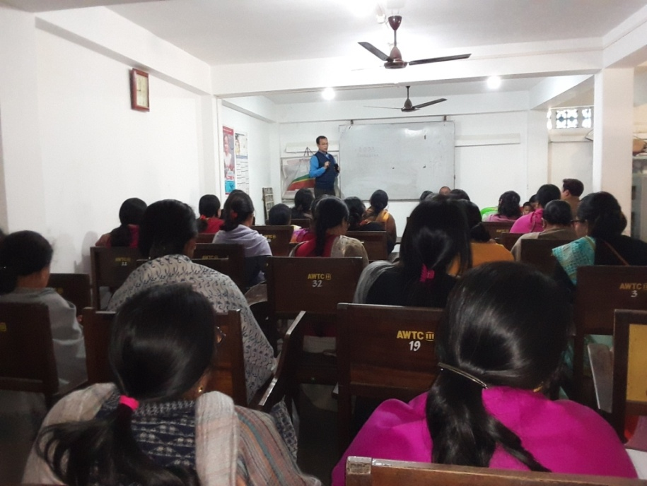
The One Day Capacity Building Programme with ICDS workers on Child Rights to Protection in Collaboration with Social Worker Association was held at the Association of Professional Social Workers Manipur, Chingamakha, Imphal West on 22 February, 2020. Altogether 49 members, of whom 40 were Anganwadi Workers from different centers participated the programme.
The Coordinator WIDE ANGLE, Ibemcha started with a warm welcome speech appreciating and encouraging the ICDS workers and the roles they undertake in development of a child in their locality. She interacted with the participants on what they know by who is a child, what are rights of the child and what they know about protection of a child. She highlighted on issues that harasses and violates the rights of a child, rising incidences of early child marriage and adolescent groups becoming vulnerable target of various forms of trafficking, the vulnerability that makes a child commit an offence and the redress mechanisms available under ICPS. She urged the workers to take advantage of such programme to strengthen their capacity in dispensing their work.
Shri S. Sarat Sharma, former Director of Social Welfare Department, Manipur elaborated on the present Scheme for Adolescent Girls in the State, the participants were asked to share their roles and the component that is being followed in the present SAG as implemented by Social Welfare Department.
Shri Keisham Pradipkumar, consultant WIDE ANGLE and Core member MACR elaborated on issues of offences against a child, and the redress mechanisms available vis-à-vis the provisions of the POCSO and JJ Act ie., CWC and JJB and on the basic Do and Don’ts in dealing CNCP and CCL implemented under the aegis of Social Welfare Department under the ICPS in the State.
Ms. Nanao Laishram, Project Coordinator of Wide Angle, CRY, Senapati took an interactive session on the 4 Fundamental Rights Of Child, Role n responsibilities of AWW, significance and formation of VLCPC, demo of Childline, when and where to approach CWC on CR Issues. She made the programme lively with round of interaction with the participants.
2 Days Meal MIS- Capacity Building Programme on CRY Pragati for Manipur Partners
The 5th and 6th March was occupied with 2 Days Meal MIS- Capacity Building Programme on CRY Pragati for Manipur Partners which was conducted at Tribal Research Institute, Chingmeirong, Imphal. The Workshop was attended by 15 participants from Wide Angle and NEEDS Chandel. The first day was mainly focused on the issues and challenges working with the MIS CRY Pragati and the second day was focused on Project holder and project coordinator and also with the upcoming new software that is expected to start from month of April.
MASS SOLIDARITY MEET ON CHILD RIGHTS
A day long mass solidarity meet on child rights was held on 30th of July 2019 at Keishampat Lairembi Community Hall. The programme was organised by WIDE ANGLE, MACR and CRY which was supported by different organizations of Manipur. Shri Khaidem Mani, Chairperson in charge, Manipur Human Rights Commission chaired the said program along with Shital Yumnam, Gen Sec. Democratic Students Alliance of Manipur (DESAM), Shanta Khurai, Secretary All Manipur Nupi Manbi Association (AMANA), Edina Yaikhom, Secretary Extra Judicial Execution Victims Family Association Manipur (EEVFAM), Ranjana Manoharmayum, Retd. Deputy Director Social Welfare Dept., Nonibala Narengbam, Secretary Integrated Rural Development Service Organisation (ISRDO), Banerjee Huidrom, Gen. Sec., Apunba Ireipakki Maheiroi Sinpan Lup, Keisham Pradip, former member MCPCR and core member WIDE ANGLE, Montu Ahanthem, MACR Convener and Sec. WIDE ANGLE.
The main objective of the meet was to demand for the
- Justice of Babysana who was found dead hanging inside the hostel of Standard Robarth Higher Secondary School, Canchipur, Imphal West under suspicious circumstances;
- Enforcement of Regulatory Guidelines for Hostels; and
- Implementation of Manipur Child Protection Policy.
Montu Ahanthem, Sec. WIDE ANGLE gave a welcome speech and a brief about the current situations of children in the state. He recalled a few past incidents of child abuse that happens in the state and call for the need of urgent implementation of State Child Protection Policy. He mentioned that the incident happened to Babysana is not the first one but many had happened in the past years too.
Shital Yumnam, Secretary of DESAM, narrated about certain conditions of hostels in Manipur that they have witnessed while going for an inspection in different places of Manipur. They found the hostel of TG Higher Secondary School, the Government school was found with common bathrooms made of bamboos. There were many other hostels that do not have a proper kitchen, toilets, rooms etc. They have been demanding for proper guidelines of school as well as hostel since many years and the Government did not put an eye on the matter. He asked to continue to raise more awareness of these issues until Government Issue the regulatory guidelines for hostel and adoption of State Child Policy.
N. Nonibala, Secretary ISRDO, Wangjing, Manipur also Director of Childline Thoubal shared about a real incident of a boy whose parents in turn blamed him for not being good to his teacher although the boy kept complaining about the immoral behaviour of one of his teacher. This is an example of how some parents mistreat their child that leads to a very unbearable condition for the child and looses their trust upon the elders. She also added that as people gets busy with their work, often forget to take care of their children and put them in hostel at an early age without observing how hostels and schools are actually treating their kids. Such carelessness of the parents led to unwanted incidents at some points. She requests everyone to take the same responsibility to take care of children and that it is not only for the child activist to work for children.
Shanta Khurai, Secretary, AMANA shared the problem face by the Trans minor. There are many sexual assault or abuse cases of transgender that goes unreported. Even though it is clearly mentioned in the POCSO Act that the act refers to gender neutral, when cases happens with the transgender, people get confuse in which shelter homes the victim is to be put. She also appeals the Government to enforce State Child Policy and frame Gender Policy.
Keisham Pradipkumar, former Member MCPCR and the core member of MACR questions why the government of Manipur took much time to notify a regulatory guideline formed by NCPCR, 2018. From 2014 MCPCR has been giving pressure to form a regulatory guideline for hostels and many cabinet meetings were held but no one raised the needs to frame guidelines. He added that the Government shows interest momentarily but forgets when people cools down.
Addressing the gathering Manipur Human rights Commission acting chairperson Khaidem Mani conveyed that the commission has taken up a Suo moto case in connection with the suspicious death of N. Babysana and met the Director General of Police on 20 July 2019 asking the latter to submit the investigation report of the case within August 11. He said that the commission will decide future course of action to expose the hidden truth, if any, behind the mysterious death at the earliest after going through the investigation report. He also informed that the Commission has directed the Commission (Education) and Education(S) director to suggestions, lying out guidelines for school boarding/hostels within 30 September 2019. And he assured of implementation of State Child Policy for safety and security of students by the commission.
After the end of the first session of the Solidarity Meet, a candle light protest was staged in front of the Western Gate of Kangla in the evening against the mysterious death of Babysana. And the following resolutions were made during the meet-
- Approve and enact the State Child Policy- which has been submitted to the State with recommendation by Manipur Commission for Protection of Child Rights (MCPCR).
- Notify the “NCPCR Regulatory Guidelines for Hostels of Educational Institutions 2018” immediately.
- Provide necessary arrangement to the 36 inmates of deceased students Babysana with Trauma Counselling facilities to reduce Post Exposure stress disorder and to enable them to co-operate to the investigation process.
Fact finding visit at Standard Robarth Higher Secondary School on suspicious death of N. Babysana Devi
On 18th of July 2019, N. Babysana Devi a class VII student of was found death hanging in hostel room in a suspicious way. The WIDE ANGLE team visited the school on 22nd July and met with the Ph. Landhoni Devi, Principal and Ph. Romikanta, former Adminstrator Higher Secondary Block and talked about the said incidents, she claimed that the child was found hanging on her bed. She clarified the rumors about delay in reporting and not allowing the parents to enter into the hostel room were the child was found death was due to confusion over two children with similar name. They took some minutes to identify the children and they wait for the forensic team to arrive at the crime scene so the parents were not allowed to enter into the hostel room until the forensic team arrived. But they were allowed to enter the room after the forensic team arrived. Later the team went to meet the parents of Babysana at Thangmeiband. But couldn’t with their parent as they went to the police station. The team met with the Joint Action Committee against the Suspicious Death of N. Babysana Devi. Meanwhile the brother of the Babysana’s father came and told that they couldn’t get the post mortem report. WIDE ANGLE suggest taking the report and if they fail to give the report then we could complain to them.
Fact Finding -Victims’ Compensation Scheme
Since the team WIDE ANGLE could not get through the thorough details of various beneficiaries of Victims’ Compensation Schemes of POCSO cases whose compensation is yet to be disbursed or are facing prolong delayed, the team made a plan to make a fact finding visits and in this regard few visits have been made with the victims’ family.
Compensation Scheme for Women Victims/Survivors of Sexual Assault/ other Crimes
Women Helpline gave a reference call to guide a case of Compensation of POCSO Victim who was entangled in the circled of institutional procedures facing many inconveniences. It is found out that the case is of 2016 October and final verdict was in June 2016 with an order for compensation of Rs. Five lakhs under Compensation Scheme for Women Victims/Survivors of Sexual Assault/ other Crimes -2018. The 19 year old Victim herself is running around for the said compensation with a hope that she can at least start a source of earning from the little share for her 3 years old son out of the unfaithful incident.
WIDE ANGLE came across the challenges that are being faced by the victims and their family and the wantings in officials discharging their departmental duties. It is also found out that no where the component of reservation of separate fund for POCSO Victims compensation seems visible and that it is managed as per the demand from time to time hardly reserving for one or 2 cases for such Compensation.
The need to come in close coordination with the officials of Departments were felt and upon which the team and Director Relief and Rehabilitation proposed for a meeting in future.

ANNUAL CHILDREN CULTURAL MEET 2019
The State Level Children Cultural Meet 2019 was organized on 5th of October 2019 at the Auditorium of the Tribal Research Institute, Chingmeirong, Imphal East. The theme of the Meet was “Break the Silence, End Child Sexual Abuse, Let’s Make a Child Friendly Manipur” which is indeed a continued theme of the previous year. Altogether about 700 people attended the programme among which around 500 were children from all the districts. The Titular King of Manipur Eningthou Leishemba Sanajaoba, Former Chairperson of Manipur Commission for Protection of Child Rights Shri S. Saratchandra Sharma, Associate General Manager of Child Rights & You (CRY) Shri Ashimkumar Ghosh graced the function as Chief Guest, President and Guest of Honor respectively. Various special invitees from different departments of the State also attended the Meet.
The Secretary of WIDE ANGLE, and also the Convenor of MACR Shri Montu Ahanthem gave the keynote address of the program stating that the cultural meet is a medium to exchange the idea of cultural integrity of different communities of the state as Manipur is a land of diverse communities & cultures. It envisages providing a golden opportunity for showcasing their innate potential & artistic talents. Performance of indigenous dances, folk songs and music, martial arts and short plays by the children hailing from different districts marks the Cultural Meet. The very inter-community mega cultural event envisions inculcating the young minds with sense of peaceful co-existence, spirit of communal harmony and emotional integrity of the state.
Addressing the gathering, Chief Guest of the program, His Royal Highness Eningthou Leishemba Sanajaoba expressed his warm welcome to the children from different communities who were participating in the programme. He also mentioned that such gathering will enhance the sense of nationalism & patriotism in the future. Besides formal education such cultural meet will also help the children to learn and explore new things.
This year, four eminent individuals working in the field of juvenile justice, journalism, education, combating drugs and alcoholism, with extraordinary efforts and commitments have been awarded Child Rights Award 2019 in the meet. The awardees are:
- Rinku Khumukcham, Editor of Imphal Times
- Thiyam Rajkishore, Chairperson CWC, Imphal West
- Thounaojam Brinda, Addl. SP NAB
- Arambam Anilkumar, ZEO Zone-III Thoubal
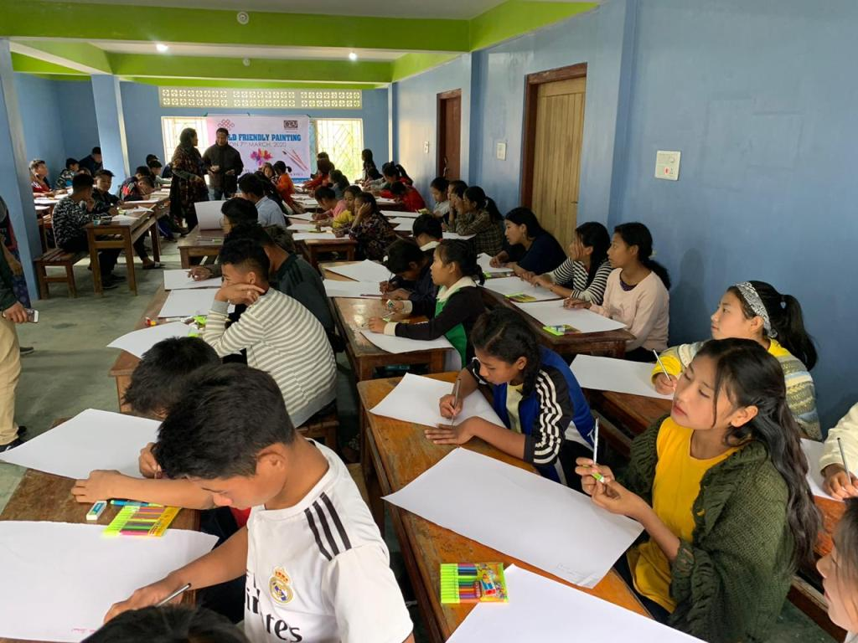
Ms. Pooja Elangbam, IAS gave an inspirational speech to the children, narrating the needs of change in the present education system existing in the state which aims at only formal education. She encouraged the children to take part in every extra curriculum activities besides studies which will help them enhancing their knowledge and develop personalities within one self. During the programme, varieties of indigenous dances, folk songs, music, martial arts and short plays were presented by the children from different districts of the state.
Child Friendly Drawing Competition : On 7th March 2020 WIDE ANGLE had participated in the Child Friendly Drawing Competition, participated by a total number of 100 children belonging to various schools and CCIs at Compassion Children Home, Senapati district, organized by CRY, the Competition was held with an objective to let out the inner most understanding of sadness that had touch the children’s mind through their drawings. The result was on average satisfactory that children participated and tried to capture the moments they felt is most sadness.
Seeking Intervention of Manipur Human Rights Commission for ensuring Food Security to children during Nationwide Lockdown
On 28th March 2020, the Executive member Mr. Keisham Pradipkumar, MACR lodged a Complaint to Manipur Human Rights Commission for the intervention of the Commission in connection with the proper implementation of Mid Day Meal, ICDS, ICPS through a special arrangement during nationwide lockdown taken up in view of the Covid-19 pandemic.
WIDE ANGLE Sec and MACR Convenor Mr Montu Ahanthem made a Press release with gratitude towards MHRC for the immediate response upon the complaint put up from MACR and WIDE ANGLE and for passing directives to concerned authorities of State Government to provide entitlements of food along with sanitary items covering all the 64 CCIs in the State of Manipur.

The MACR Executive member Mr. Keisham Pradipkumar had written for inclusion of Basic Child Rights Laws in the syllabus of Police training to the Director, Manipur Police Training College, Pangei Imphal East that remained on desk due to the curfews and lockdowns against prevailing situation of pandemic Covid 19.
The month of March was full of schedules as well as plan of action, with the unfortunate pandemic engulfing the whole world has eclipse everything at halt, however, what could be done through help of virtual internet is being underway.

